BEES FOR SALE APRIL 2020
DESCRIPTION OF HIVE, eg NATIONAL CEDAR, HOME-MADE NUC etc
Maismore 6 Frame Poly Nuc ………………………………………………………………………………………………………………………………………………………………………..
COMPRISES, OPEN MESH FLOOR, BROOD, FEEDER
…………………………………………………………………………………………………………………………………………………………………………
TYPE OF FRAMES, HOFFMAN (DN4)
……………………………………………………………………………………….
NO OF FRAMES OF BEES (with date) ………5…………4/20…………………………………….
NO OF FRAMES OF BROOD (with date) …4 ……4/20……………………………………
VARROA TREATMENTS (last 12 months) ……APIVAR SEPT 2019.
APIBIOXAL JAN 2020…………………………………………………………………………………………………………………..
AWAITING BEE INSPECTOR (when) …APRIL 20……………….
AGE OF QUEEN (marked/clipped?) ……………2019 MARKED………………………….
OTHER DETAILS… …………..…..CALM BEES……………………………………………………………………………………
COLLECTION OR DELIVER…………BY ARRANGEMENT………………………………………………………
CONTACT DETAILS (location, name and phone no)
GILLIAN THATCHER, DRIFFIELD 07787414060 gillianthatcher@btinternet.com……………………………
£…165………...

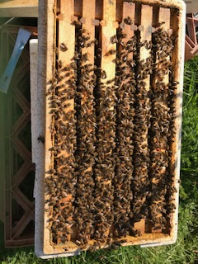

N.B. DUE TO EXTRAORDINARY CIRCUMSTANCES WHICH EXIST AT THE MOMENT, BEVERLEY BKA ARE OFFERING THIS FREE FACILITY TO PEOPLE WISHING TO BUY OR SELL BEES
All arrangements entered into are strictly between vendor and buyer. Beverley BKA do not accept any liability for the accuracy of the information provided.

