BEES FOR SALE APRIL 2020
DESCRIPTION OF HIVE, eg NATIONAL CEDAR, HOME-MADE NUC etc
………………………………………………………………………………………………………………………………………………………………………..
COMPRISES, eg OPEN MESH FLOOR, BROOD, WIRED QUEEN EXCLUDER, SUPER, CROWN BOARD, 4” ROOF
…………………………………………………………………………………………………………………………………………………………………………
TYPE OF FRAMES, eg HOFFMAN (DN4) …………………………………………………………………………………………………………….
NO OF FRAMES OF BEES (with date) ……………………………………………………….
NO OF FRAMES OF BROOD (with date) ……………………………………………
VARROA TREATMENTS (last 12 months) ………………………………………………………………………………………………………………………..
LAST INSPECTED BY BEE INSPECTOR (when) …………………………………………………….
AGE OF QUEEN (marked/clipped?) ……………………………………….
OTHER DETAILS……………………………………………………………………………………………………………………………………………………………...
COLLECTION OR DELIVER…………………………………………………………………………
CONTACT DETAILS (location, name and phone no)
………………………………………………………………………………………………………………………………………………………………………………………
PRICE REQUIRED £…………...
PICTURE OF SALE ITEM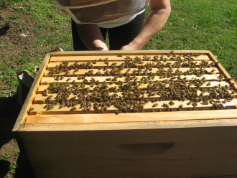
EXAMPLE

N.B. DUE TO EXTRAORDINARY CIRCUMSTANCES WHICH EXIST AT THE MOMENT, BEVERLEY BKA ARE OFFERING THIS FREE FACILITY TO PEOPLE WISHING TO BUY OR SELL BEES
All arrangements entered into are strictly between vendor and buyer. Beverley BKA do not accept any liability for the accuracy of the information provided.

